October STEM
Hurricanes!
Imagine a force that can toss boats around like toys, wash away bridges, and create waves as high as 18 feet. With fierce winds and torrential rains, hurricanes can do all of these things. For centuries people did not know when a hurricane was coming.

Standards

Challenge
Create a weather instruments, anemometer, rain gauge, barometer, wind vane that a meteorologist would use during a hurricane. These instruments must be able to show changes in the weather, air pressure, rain amounts, wind speed, or direction.
Constraints
  - Must be able to use the weather instrument
  - Must be able to show changes in the weather
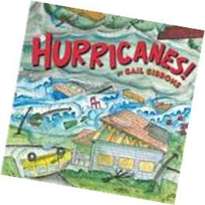
Material
- Sticks
- Tape
- Straws
- Balloons
- String
Tools
- Ruler
- Scissors

